

|  |  |  |  |  |  |  |  |
| --- | --- | --- | --- | --- | --- | --- | --- |
|  | | | | | | | |
|  | | SPI slave with single port RAM | | | |  | |
|  |  | | | | | |  |
|  | | | Teammates:  Abdulrahman Mohammad Abdelrahman Ahmed Sayed | |  | | |
|  | | | Under Supervision of: Eng. Kareem Waseem |

**Snippets from the waveforms captured from QuestaSim**

**1_testing synchronous reset**

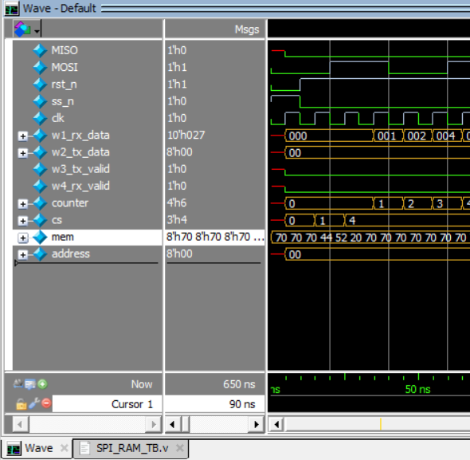

**2_testing read address**

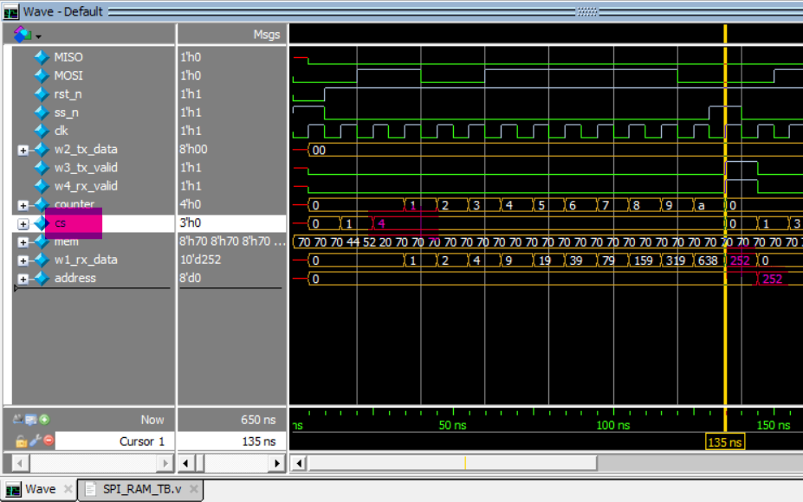

**3_what was in the address**

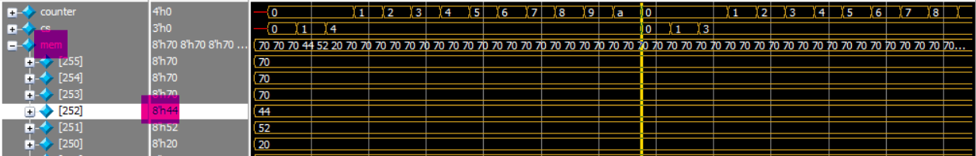

**4_testing read data**

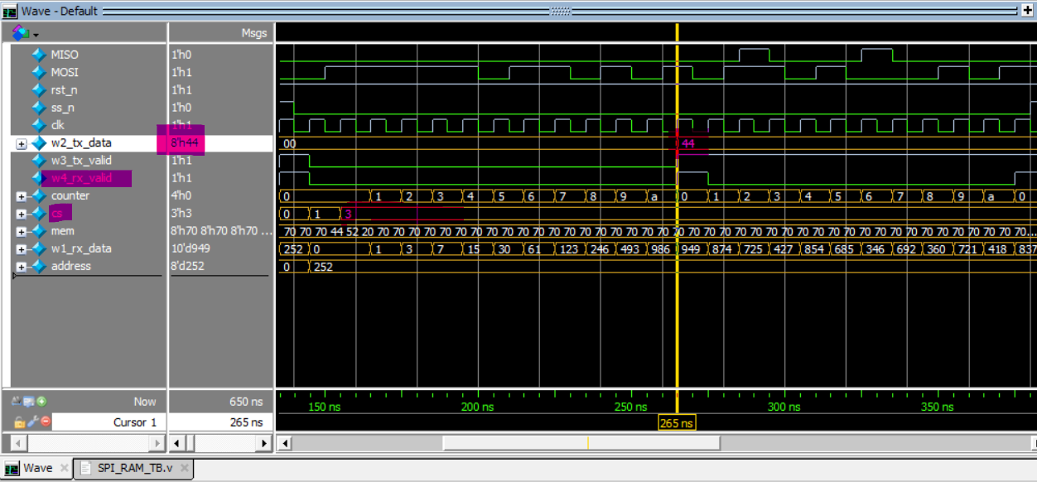

**5_test write address**

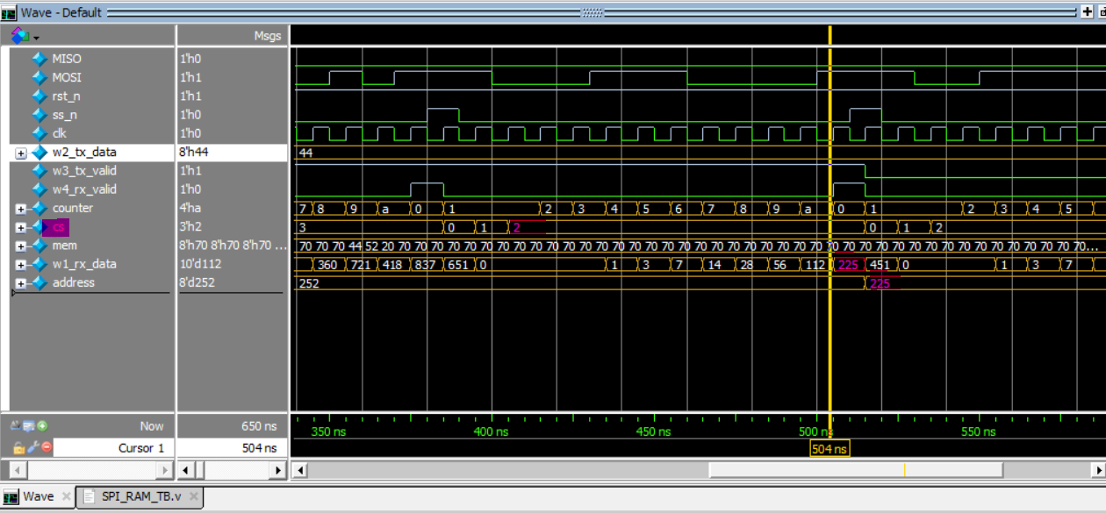

**6_testing write data**

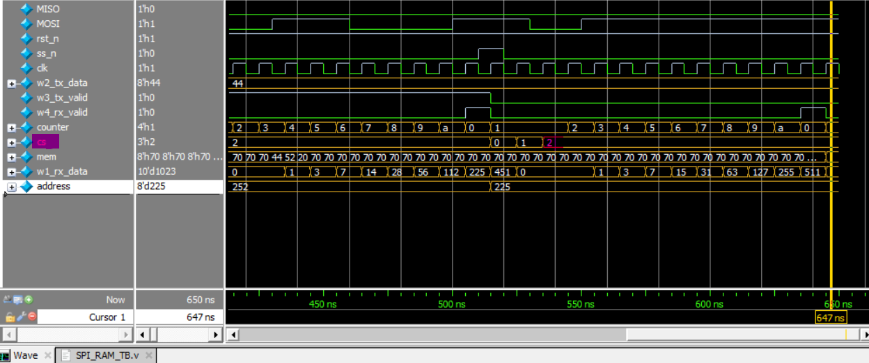

**7_what we wrote in TB is written in the address we determined**

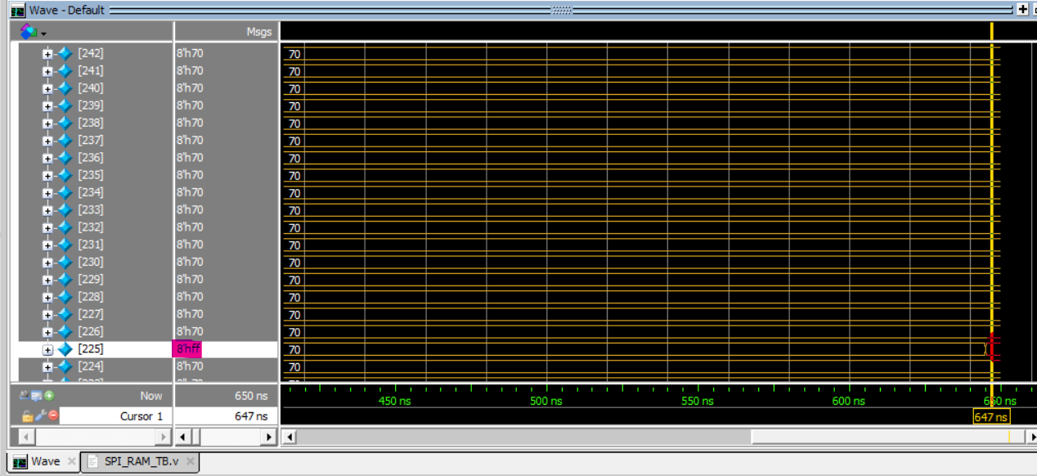

**Questa Lint**

**VIVADO**

**(* fsm_encoding = "gray" *)**

**Schematic elaboration  
**

**Schematic Synthesis**

Encoding from report

**Timing report**

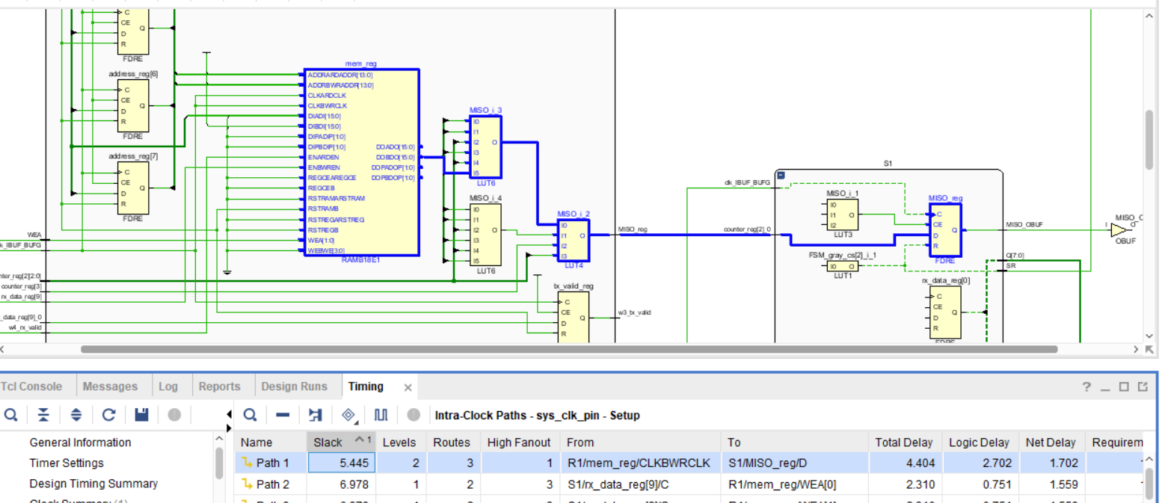

**Implementation**

**Device:**

**(* fsm_encoding = "one_hot" *)**

**Elaborator**

**  
  
Schematic Synthesis:  
**

**Encoding Report:**

**Timing report:**

**Implementation:   
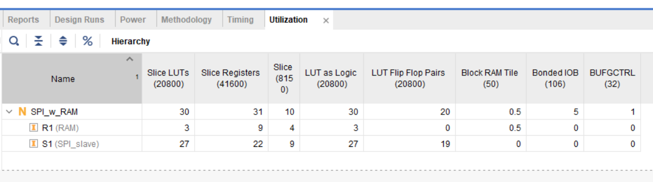  
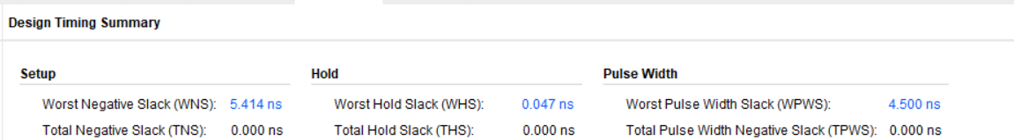**

**(* fsm_encoding = "sequential" *)**

**

Encoding report

Timing report:

**Implementation  
  
**

**(* fsm_encoding = "johnson" *)**

**Synthesis schema**

**Encoding Report:  
**

**Timing report**

**Implementation**

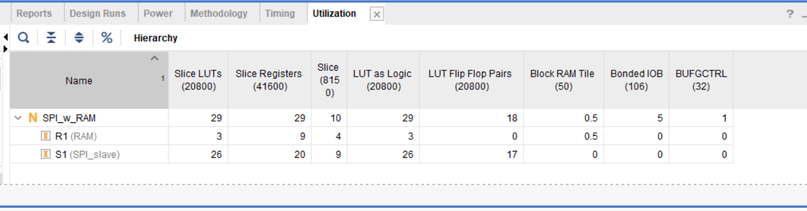

**Massages:  
**



